

SEKA KAMA
AI DRIVEN COMMUNITY BASED MONITORING AND EARLY WARNING SYSTEM FOR EAST AFRICAN LION CONSERVATION

SYSTEM DOCUMENTATION

BY
JAMES MWAURA
REGISTRATION NUMBER: DSE-02-0143/2025
SEPTEMBER 2026

DECLARATION
I declare that this project documentation is my original work and has not been submitted for assessment in another institution. All works by other authors will be acknowledged through appropriate citation.

Student: James Mwaura
Registration No.: DSE-02-0143/2025
Signature: ______________________________ Date: __________________
Supervisor: _____________________________ Date: __________________

DEDICATION
This documentation is dedicated to the conservation practitioners, communities and researchers whose daily work sustains the Greater Mara landscape.

ACKNOWLEDGEMENT
I acknowledge the guidance of my supervisor, the conservation practitioners who informed the problem definition, and the open scientific and technical communities whose published work supports this project.

ABSTRACT
This project document will specify, the design, develop and evaluate a proposed geospatial decision-support platform for East African lion conservation in the Greater Mara ecosystem. It responds to the need to bring ecological indicators, spatial evidence and scenario analysis into a usable planning workflow. Authorized planners and researchers will be able to select an area, define a land-use or habitat scenario, compare modelled results with baseline conditions and inspect mapped and numerical outputs. Work commenced from September12, 2026, following six milestones; which are as follows: planning and analysis; interface and logic design; two stages of development and testing; deployment; and final documentation. The proposed design will draw on a web interface, API services, spatial data and an XGBoost prediction service. Evaluation will cover functional behavior, model and data limitations, performance, security and user acceptance. Predictions will serve as decision-support evidence for review alongside field observations and professional judgement.

DEFINITION OF KEY TERMS
Term | Definition
Digital twin | A computational representation of a real-world system connected to data for examining current states or scenarios.
Geospatial intelligence | Actionable information derived from location-based data and analysis.
Greater Mara | The Maasai Mara National Reserve and neighbouring conservancies within the study boundary.
XGBoost | A gradient-boosted decision-tree method proposed for ecological prediction.
PostGIS | A PostgreSQL extension for storing and querying geographic data.
Scenario | A set of proposed feature changes applied to a selected area for comparison with a baseline.
Baseline | The reference data and model output used for scenario comparison.
Human-wildlife conflict | Interactions between people and wildlife that cause or risk harm to people, livestock, property or wildlife.
UML | Unified modeling language
ERD | Entity relationship diagram
DFD | Data flow diagram
Key terms used in this document are defined in Table 0.1. The definitions describe how each term is used in the Seka Kama workflow.

ABBREVIATIONS AND ACRONYMS
Acronym | Meaning
AI | Artificial Intelligence
API | Application Programming Interface
DSR | Design Science Research
ERD | Entity-Relationship Diagram
GIS | Geographic Information System
GPS | Global Positioning System
IoT | Internet of Things
KWS | Kenya Wildlife Service
ML | Machine Learning
NDVI | Normalized Difference Vegetation Index
REST | Representational State Transfer
SDLC | Software Development Life Cycle
UAT | User Acceptance Testing
VIIRS | Visible Infrared Imaging Radiometer Suite
WDPA | World Database on Protected Areas
XGBoost | Extreme Gradient Boosting

TABLE OF CONTENTS
Contents
DECLARATION 2
DEDICATION 3
ACKNOWLEDGEMENT 4
ABSTRACT 5
DEFINITION OF KEY TERMS 6
ABBREVIATIONS AND ACRONYMS 7
TABLE OF CONTENTS 8
LIST OF FIGURES 10
LIST OF TABLES 11
CHAPTER ONE: PROJECT PLANNING AND ANALYSIS 12
1.1 Statement of Problem 12
1.2 Study Justification 12
1.3 System Objectives 12
1.3.1 General Objective 12
1.3.2 Specific Objectives 12
1.3.3 Research Questions 12
1.3.4 Working Hypothesis 13
1.4 Functional Requirements 13
1.5 Non-Functional Requirements 13
1.6 Scope and Delimitation 14
1.7 Tools and Resources 14
1.8 Project Schedule Breakdown 16
CHAPTER TWO: PROJECT DESIGN 17
2.1 Overview of the Proposed System 17
2.2 Users and Roles 17
2.3 Proposed User Interface Design 17
2.4 Architecture and Logic Design 19
2.5 Data Flow 20
2.6 Entity-Relationship Design 21
2.7 Scenario Processing and Proposed Sample Code 21
2.8 Data Quality, Privacy and Security 22
2.9 Chapter Summary 22
2.9 UML views of the proposed system 23
UML component view 23
UML sequence view 24
UML deployment view 24
CHAPTER THREE: PROJECT DEVELOPMENT, TESTING AND DEPLOYMENT 25
3.1 Development Plan 25
3.2 Data and Database Development 25
3.3 Feature Development Plan 25
3.4 Testing Plan 25
3.4.1 Acceptance Measures 26
3.5 Deployment Plan 26
3.6 Maintenance Considerations 27
CHAPTER FOUR: TECHNICAL IMPLEMENTATION AND OPERATIONAL DOCUMENTATION 29
4.1 Map and Geospatial Workspace 29
4.2 Spatial Data Pipeline 29
4.3 Prediction and Scenario Services 30
4.4 API and Data Contracts 30
4.5 Deployment and Configuration 30
4.6 Reproducible map implementation specification 31
4.7 Exact model feature inventory 32
4.8 Methodological limits and unresolved definitions 34
CHAPTER FIVE: CONCLUSIONS AND RECOMMENDATIONS 34
5.1 Conclusion 34
5.2 Recommendations 34
5.3 Areas for Further Work 35
REFERENCES 35
APPENDIX A: PROPOSED SCREEN INVENTORY 36
APPENDIX B: ILLUSTRATIVE SCENARIO REQUEST 36

LIST OF FIGURES
Figure 2.1 Conservation visual reference [ Page. ]
Figure 2.2 Proposed Next.js/React and MapLibre GL JS workspace reference [ Page. ]
Figure 2.3 Platform context diagram [ Page. ]
Figure 2.4 Level-one data-flow diagram [ Page. ]
- Figure 2.6 UML component view [ Page. ]
- Figure 2.7 UML sequence for scenario processing [ Page. ]
- Figure 2.8 UML deployment view [ Page. ]
Figure 2.5 Entity-relationship design [ Page. ]

LIST OF TABLES
- Table 1.1 Functional requirements [ Page. ]
- Table 1.2 Non-functional requirements [ Page. ]
- Table 1.3 Tools and resources [ Page. ]
- Table 1.4 Schedule [ Page. ]
- Table 2.1 User roles [ Page. ]
- Table 2.2 Core entities [ Page. ]
- Table 3.1 Development plan [ Page. ]
- Table 3.2 Testing plan [ Page. ]
- Table 3.3 Deployment activities [ Page. ]

CHAPTER ONE: PROJECT PLANNING AND ANALYSIS
This chapter defines the conservation problem, the purpose of the platform, its scope, requirements, resources and delivery schedule.

1.1 Statement of Problem
Lion conservation in the Greater Mara depends on timely information about habitat conditions, human activity and human–wildlife conflict risk. Complemented by field observations, incident records, satellite products and spatial datasets may be held in different formats and reviewed at different times by differ4ent stakeholders across the board. This fragmentation can make it difficult for planners to examine how a proposed land-use change could affect ecological conditions across a selected area. Seka kama will address this planning gap through a geospatial workflow that combines baseline indicators and scenario analysis. Users will identify a geography, specify a change and review a modelled comparison with its assumptions and limitations. The generated result is designed to inform, instead of replacing: field evidence and professional judgement.

1.2 Study Justification
A spatial scenario workflow is justified since conservation and land-use decisions are place-specific and involve interacting indicators. The digital-twin approach connects reference layers, modelling and review through the Next.js/React workspace, MapLibre GL JS, Mapbox tiles and the FastAPI geospatial services. The use of this web workspace and these geospatial services will be under study to show how it all might be used to support repeatable analysis for conservation planners and researchers. Satellite telemetry and nightlight trends are intended sources in the proposal; their access, permissions, temporal coverage and integration will be confirmed during requirements analysis.

1.3 Existing Systems and Comparative Gap
Existing conservation systems demonstrate that the problem is technically tractable, but they address different operational needs. The comparison below is based on the published capabilities of each system and is used to define the gap for this project. It does not claim that Seka Kama replaces any of them.
SMART is a conservation monitoring and reporting platform with mobile, desktop and cloud components. It supports structured patrol and observation data, analysis and reporting across a conservation area. Its primary strength is operational monitoring and reporting. The project requirement that remains open is a scenario workflow that modifies spatial predictor values and compares modelled outcomes against a baseline.
EarthRanger is a real-time conservation platform that integrates GPS collars, camera traps, patrol reports and remote sensors into a unified map view. It supports wildlife, personnel and vehicle tracking, offline field collection and configurable alerts. Its primary strength is operational awareness and response. This project addresses a different analytical need: scenario-based comparison of habitat and human-pressure variables for conservation planning.
ArcGIS provides mature spatial analysis, suitability modelling and conservation-planning workflows. It is a general GIS environment rather than a single lion-conservation scenario service. Its strength is broad geoprocessing and professional cartography. Seka Kama narrows the workflow to an authenticated web workspace, an approved feature vector, an XGBoost prediction service and a reproducible scenario record.
Table 1.1 Existing-system comparison
System | Primary purpose | Relevant capabilities | Limitation relative to this study | Source
SMART | Conservation monitoring and reporting | Mobile, desktop and cloud components; structured patrol and observation data; analysis and reporting. | Not documented here as a purpose-built workflow for changing model predictors and comparing predicted lion outcomes. | SMART 7 overview, World Bank: https://thedocs.worldbank.org/en/doc/43c89c4a946e031980277302e3072960-0320052022/original/poaching-spatial-management-and-reporting-tool-smart.pdf
EarthRanger | Real-time wildlife and protected-area operations | Integrates GPS collars, camera traps, patrol reports and sensors; unified map; offline collection; alerts. | Designed around monitoring and response rather than the specific baseline-versus-scenario modelling workflow proposed here. | EarthRanger Support: https://support.earthranger.com/en_US/what-is-earthranger-and-how-does-it-work
ArcGIS conservation workflows | General GIS analysis and conservation planning | Suitability modelling, spatial analysis, prioritisation and mapping. | Broad platform; the proposed study defines a narrower, web-based, model-linked scenario workflow for the Greater Mara. | Esri Conservation Planning: https://www.esri.com/en-us/industries/conservation/focus-areas/planning
Seka Kama proposed platform | Scenario-based lion conservation planning | Mapbox/MapLibre GL JS workspace; GeoJSON area selection; PostGIS spatial query; 43-feature model vector; XGBoost prediction; baseline comparison; scenario history. | Requires project evaluation before claims about accuracy, operational benefit or ecological validity can be made. | This study design and implementation repository.
The comparative gap is therefore specific. Existing systems provide strong monitoring, real-time operations or general GIS analysis. Seka Kama is designed to connect a selected geography to an approved 43-feature model vector, apply permitted scenario changes, run a prediction, return baseline-versus-scenario differences and retain the request for review. The evaluation must test whether this proposed workflow is useful and valid; the comparison does not establish that it is superior.

1.4 System Objectives

1.4.1 General Objective
The main objective is to design, develop and evaluate a geospatial decision-support platform for scenario-based monitoring and conservation planning for East African lions in the Greater Mara ecosystem, and the entire sub-Saharan ecosystem by extension.

1.4.2 Specific Objectives
- Design geospatial workspace that will bring approved ecological and spatial indicators together for the study area.
- Develop a scenario workflow that will allow authorized authenticated users to define a geography and proposed feature changes, then compare modelled results with baseline conditions.
- Design map, summary and explanation outputs that will aid users to interpret scenario results and assumptions.
- Evaluate platform through: functionality, performance, security and user-acceptance activities aligned with the project milestones.

1.4.3 Research Questions
- How will selected ecological and spatial sources be integrated into a unified workflow for the Greater Mara?
- How will scenario analysis support review of potential habitat and human-wildlife pressures?
- To what extent will the proposed platform meet functional, performance, security and user needs?

1.4.4 Working Hypothesis
The proposed platform is expected to make scenario comparison more structured and accessible than reviewing disconnected spatial layers and records. Evaluation will examine this expectation; it is not presented as a measured result.

1.5 Functional Requirements
ID | Requirement
FR1 | Provide authenticated access for authorised users.
FR2 | Display a baseline map with filters for available management units.
FR3 | Allow an area of interest to be drawn or supplied as supported GeoJSON.
FR4 | Allow a user to define supported feature modifications for a scenario.
FR5 | Identify relevant grid cells and retrieve baseline features for the selected area.
FR6 | Estimate scenario outcomes and compare them with baseline values.
FR7 | Present affected geography, summary values and a plain-language interpretation.
FR8 | Retain scenario metadata and allow review of prior scenario runs.
FR9 | Allow authorised users to export appropriate map or summary material.
FR10 | Support controlled user access and review of significant activity.

1.6 Non-Functional Requirements
Area |  | Proposed requirement
Usability | Clear labels, map cues and readable explanations for non-technical conservation users.
Performance | Measure spatial queries and scenario runs against agreed test data and acceptance thresholds.
Security | Use authentication, roles, secure secret handling and input validation.
Reliability | Report data or prediction errors clearly; never present failed requests as valid results.
Data quality | Check geometry, attributes, coordinate systems and feature ranges.
Maintainability | Separate interface, API, prediction and data access responsibilities.
Accessibility | Support readable contrast, keyboard use for core controls and text alternatives.
Traceability | Retain scenario inputs, model version and processing metadata where permitted.

1.7 Scope and Delimitation
The study will focus on the Maasai Mara National Reserve and neighbouring conservancies within the defined Greater Mara study boundary, and on the East African lion. The platform will support baseline mapping, scenario definition, spatial feature selection, model comparison, result interpretation and export. Intended sources include approved satellite, land-cover, terrain, nightlight and protected-area data, and suitable conservation records when access is authorized. The project will not establish field truth for every ecological condition, guarantee real-time sensor availability or automate management decisions. Live telemetry and IoT integrations will be included only if access and technical feasibility are confirmed. Outputs will be estimates subject to data coverage and validation.

1.8 Tools and Resources
Tool / package | Version or source | Explicit responsibility | Integration point
Next.js | 16.2.6 | Application shell, routing, server/client rendering and production web build. | web-app/seka_kama/app and next.config.ts
React | 19.2.4 | Component model and client-side interaction state for the web workspace. | web-app/seka_kama/components
TypeScript | project devDependency | Typed client services, components and API contracts. | web-app/seka_kama/*.ts and *.tsx
maplibre-gl | ^5.24.0 | Renders the Mapbox basemap, camera, sources and visible map layers. | SekaMap.tsx and KeplerMap.tsx
react-map-gl | ^8.1.1 | Connects the MapLibre GL JS map instance to React components and events. | Map workspace components
@mapbox/mapbox-gl-draw | ^1.5.1 | Captures and edits scenario geometry as GeoJSON. | Scenario drawing control
deck.gl | 9.2.11 | Renders analytical grid-cell and spatial overlay layers. | Analytical map layers
kepler.gl | ^3.3.0-alpha.0 | Supports exploratory geospatial layer inspection where enabled. | Exploratory map view
recharts | ^2.15.3 | Renders trend, comparison and summary charts. | TrendChart.tsx and result panels
lucide-react | ^0.473.0 | Provides interface icons for controls and navigation. | Shared interface components
Python / FastAPI | backend requirements | Provides the HTTP API, validation, authentication and orchestration services. | backend/api, backend/core and backend/main.py
PostGIS / PostgreSQL | Docker image postgis/postgis:16-3.4 | Stores grid cells, protected areas, users, scenarios, history and audit records with spatial indexes. | backend/sql and docker-compose.yml
Supabase client | backend requirements | Provides the application data-access connection to the hosted PostgreSQL/PostGIS store. | backend/core/database.py and services
XGBoost model | backend/models/sekanet_xgboost_shp.pkl | Produces the model prediction from the ordered feature vector. | backend/services/prediction_service.py
StandardScaler | backend/models/sekanet_scaler_shp.pkl | Transforms the model feature vector before XGBoost inference. | backend/services/prediction_service.py
NASA POWER / CHIRPS | backend integration scripts | Supplies rainfall and related environmental enrichment when enabled. | backend/scripts/fetch_rainfall_*.py
GBIF API | backend/services/ecological_data_service.py | Supplies species-occurrence information used for ecological enrichment. | Ecological data service
NVIDIA NIM / OpenAI-compatible client | backend/services/llm_service.py | Generates supplementary narrative explanations with a rule-based fallback. | LLM service
Docker Compose | docker-compose.yml | Runs the PostGIS, FastAPI and Next.js services as separate containers. | Deployment configuration
JWT, bcrypt and API keys | backend authentication modules | Protects authenticated routes and supports programmatic access. | backend/api/auth_routes.py and key_routes.py

1.9 Project Schedule Breakdown
Milestone | Planned Period | Dur. | Sep '26 | Oct '26 | Nov '26 | Dec '26
1. Planning and analysis  Problem, justification, objectives, tools/resources, schedule, cover and Chapter One. | 12 – 25 Sep 2026 | 14d | ■■■
2. Project design  Identify and sketch user screens; design component logic, flowcharts, UML and ERD; Chapter Two. | 26 Sep – 9 Oct 2026 | 14d | ■■■ | ■■■
3. Development & testing (1/2)  Begin feature-by-feature implementation and debugging; database development; Chapter Three progress. | 10 – 31 Oct 2026 | 22d |  | ■■■
4. Development & testing (2/2)  Continue and integrate features; resolve defects; evaluate workflows; update Chapter Three. | 1 – 20 Nov 2026 | 20d |  |  | ■■■
5. Deployment  Prepare simulated/approved environment, configure services and verify deployment; document Chapter Three. | 21 Nov – 5 Dec 2026 | 15d |  |  | ■■■ | ■■■
6. Final documentation  Complete preliminary pages, Chapter Four, recommendations, APA 7 references and final review. | 6 – 18 Dec 2026 | 13d |  |  |  | ■■■

CHAPTER TWO: PROJECT DESIGN
This chapter describes the proposed interface, system architecture, data flows, database structure and scenario logic.

2.1 Overview of the Proposed System
The platform will connect a browser-based conservation workspace to an API, spatial data store and prediction service. A user will select an area, inspect available baseline indicators and submit a scenario. The API will validate the request, retrieve relevant features, prepare model inputs and return a result for map and summary presentation. The user will be able to review assumptions and compare a scenario with baseline conditions. The proposed technical baseline will use a React/Next.js interface, Python API services, spatial database access and an XGBoost prediction model. Final versions, schemas and hosting choices will be confirmed during project work.

2.2 Users and Roles
User group | Responsibilities | Functions
Conservation planner | Frame a planning question and compare changes. | Area selection, scenario, maps, summaries and exports.
Researcher or analyst | Review indicators, assumptions and trends. | Feature summaries, history and model context.
Data steward | Prepare and validate approved layers. | Data checks, controlled updates and metadata.
Administrator | Manage access and oversee activity. | Roles, access controls and activity review.

2.3 Proposed User Interface Design
The Next.js/React workspace will combine the MapLibre GL JS and Mapbox map canvas with a scenario panel, management-unit filters, feature-change inputs and result summaries. A sign-in screen will provide the entry point. A history/reports view will support review of saved scenarios, and settings will support authorised account management. Screen labels and control placement will be validated with prospective users during design review.

Figure 2.1 Proposed visual reference for the platform identity and conservation context.
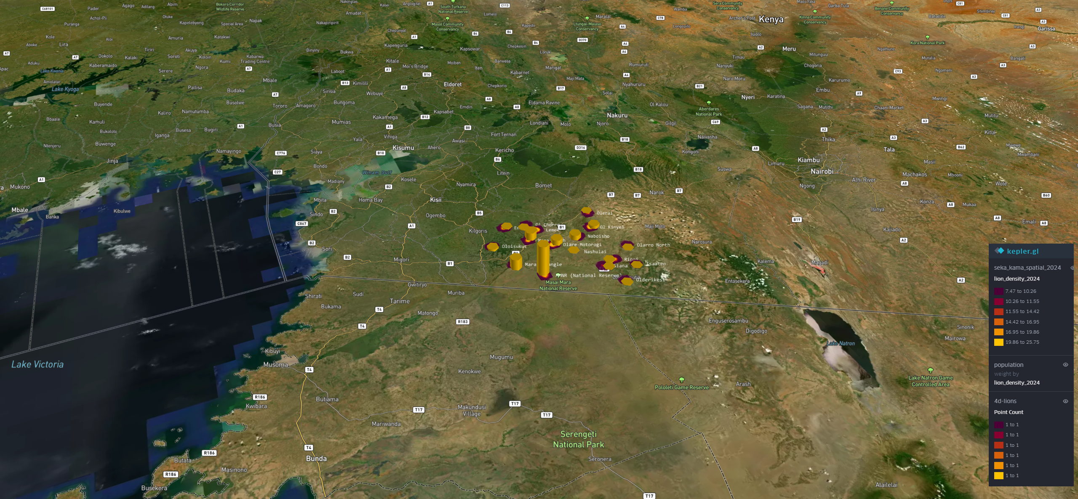
Figure 2.2 Proposed Next.js/React and MapLibre GL JS workspace reference; screen content will be adapted to the approved study workflow.

2.4 Architecture and Logic Design
The presentation layer will provide the MapLibre GL JS/Mapbox canvas, Deck.gl analytical layers and forms. The API layer will validate requests and orchestrate data access. The spatial layer will store and query geographic evidence. The prediction layer will prepare features and estimate scenario outcomes. Approved external sources will enter through a documented ingestion process. Results will return with context for interpretation.
Layer | Proposed responsibility
Presentation | Sign-in, map, scenario form, results, history and export controls.
API/application logic | Authentication, validation, orchestration, audit metadata and response formatting.
Spatial data | Grid cells, study boundaries, protected areas, management units and spatial indexes.
Prediction | Feature preparation, inference, baseline comparison and limitations.
External data | Approved satellite, land-cover, terrain, nightlight and conservation data.

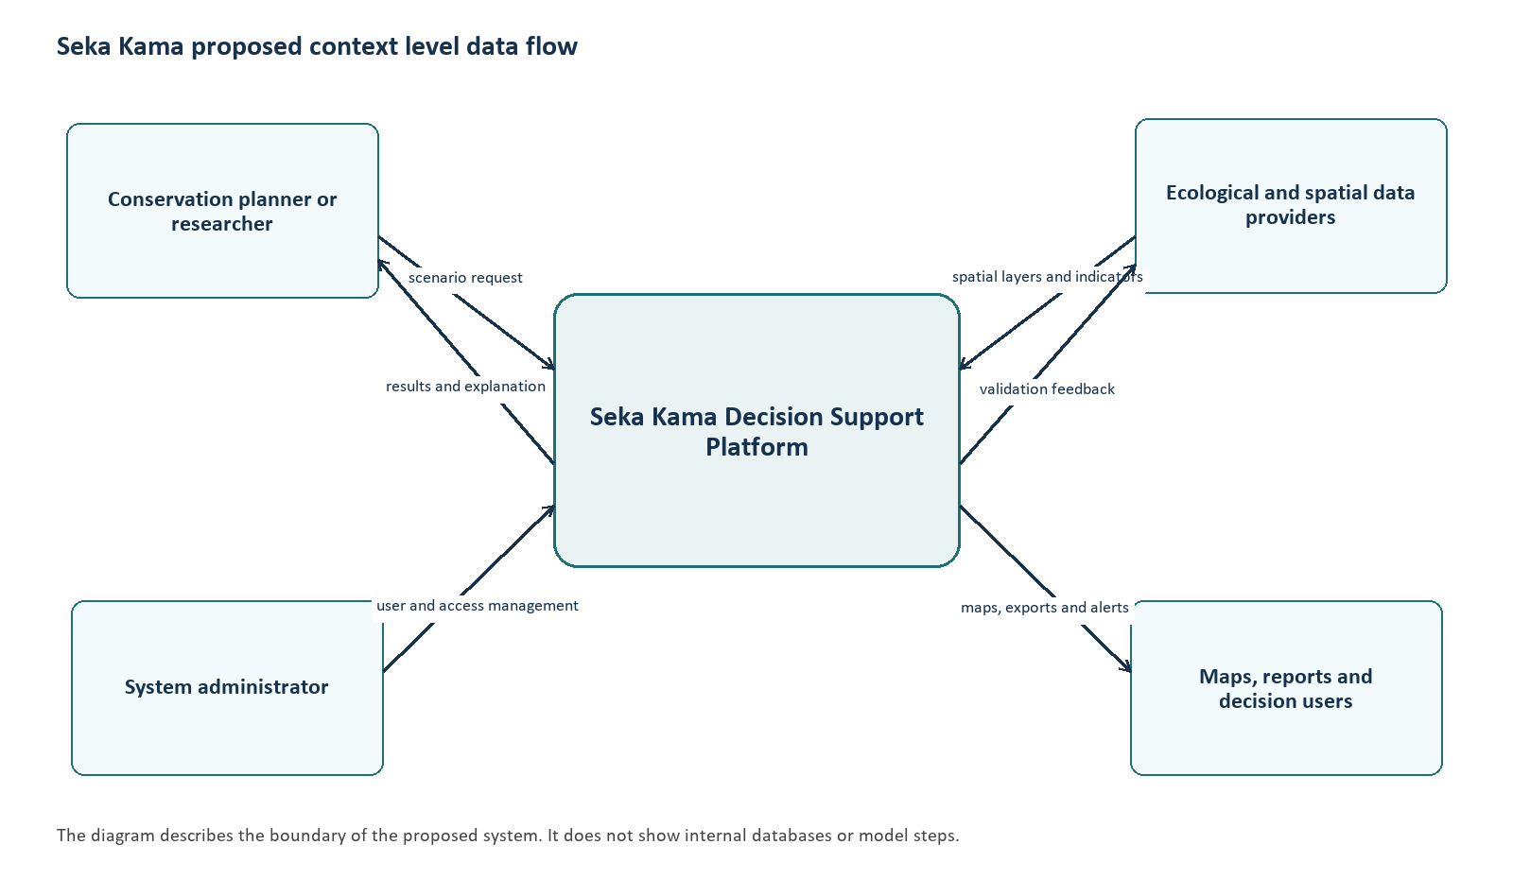
Figure 2.3 Proposed platform context diagram.
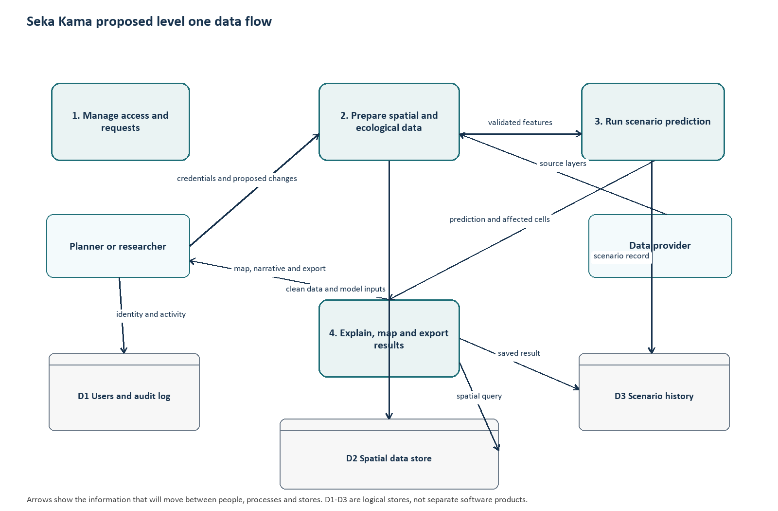
Figure 2.4 Proposed level-one data-flow diagram.

2.5 Data Flow
A scenario request will be checked for authentication, valid geometry and supported changes. The spatial service will identify intersecting analysis cells and retrieve baseline features. The preparation step will create model-ready values without changing reference records. The prediction service will calculate a scenario estimate, compare it with the baseline and prepare a map, summary and explanation. Saved records will retain only information needed for review and audit, subject to the approved data policy.

2.6 Entity-Relationship Design
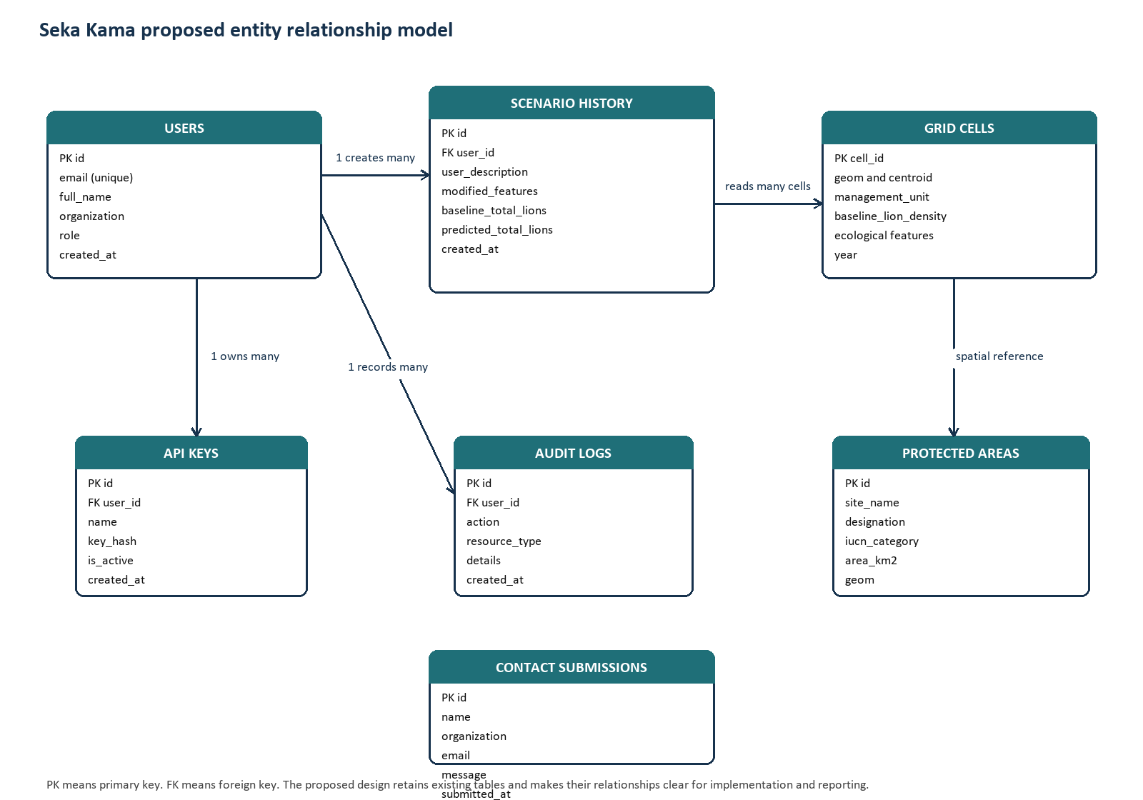
Figure 2.5 Proposed entity-relationship design for platform records.
Entity | Purpose and relationship
Users | Identity, organization, role and access status; associated with keys, scenarios and audit entries.
Grid cells | Geometry and baseline features; many cells can be selected by a scenario.
Scenario history | Inputs, selected area, baseline and predicted summaries; owned by a user.
Protected areas | Conservation boundaries for comparison with grid cells.
Audit logs | Significant access and platform actions associated with an actor where available.
API keys | Programmatic credentials associated with a user and stored securely.

2.7 Scenario Processing and Proposed Sample Code
The illustrative sample shows the intended pattern: validate a request, retrieve affected baseline features, apply permitted changes to a copy, predict and compare. Before implementation, schemas, feature names, units, authorization, error handling and model inputs will be verified.
# Proposed sample: illustrative scenario service
def run_scenario(request, spatial_store, predictor):
area = validate_geojson(request.geometry)
changes = validate_feature_changes(request.feature_modifications)
cells = spatial_store.cells_intersecting(area, request.management_units)
if not cells:
raise ValueError("No cells intersect the selected area")
baseline = spatial_store.features_for(cells)
scenario = baseline.copy(deep=True)
for name, change in changes.items():
scenario[name] = scenario[name] * (1 + change)
estimate = predictor.predict(scenario)
base_total = float(baseline["baseline_lion_density"].sum())
scenario_total = float(estimate.sum())
return {"baseline": base_total, "scenario": scenario_total,
"change": scenario_total - base_total,
"cells": len(cells), "assumptions": changes}
The workflow will not overwrite baseline data. A saved response will include scenario and model metadata once the retention design is approved. Explanations will distinguish estimates from observed events.

2.8 Data Quality, Privacy and Security
- Validate GeoJSON, geographic bounds and permitted feature names before processing.
- Use consistent coordinate reference systems; check topology, attributes and provenance during ingestion.
- Keep baseline data read-only to scenario operations; store changes with scenario records.
- Apply role-based authorization to protected data, exports and administration.
- Keep credentials outside source code and use established password hashing.
- Document sources, model versions, feature units and known limitations.
- Restrict precise wildlife locations and sensitive incident information to approved roles.
- Record significant access and administrative activity under the approved data policy.

2.9 Chapter Summary
The design will connect a MapLibre GL JS/Mapbox workflow to spatial queries and model inference through an API. The diagrams, entity model and sample logic will guide interface, database and feature development during the next milestones.

2.9 UML views of the proposed system
The UML views in this section make the design explicit. They show which component owns each responsibility, the order of a scenario request, and the runtime nodes used to deploy the system. Together with the context diagram, DFD and ER design, they provide a traceable design record for Chapter Two.

UML component view
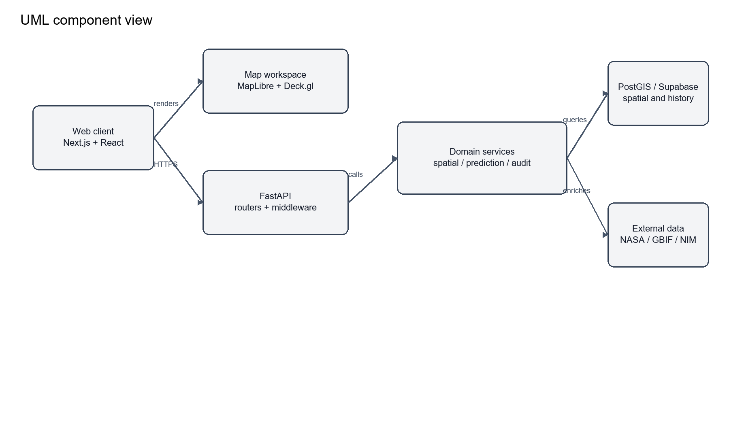
Figure 2.6 UML component view of the Seka Kama platform.

UML sequence view
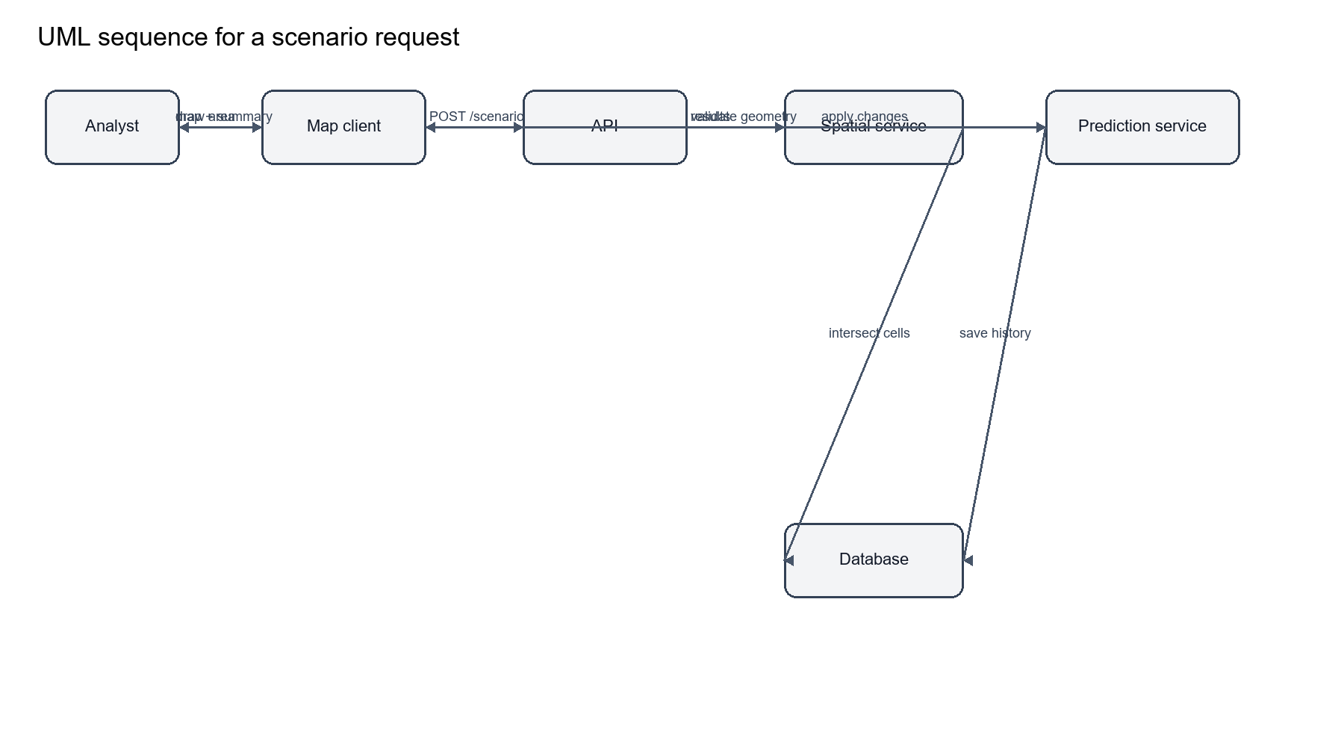
Figure 2.7 UML sequence for scenario processing.

UML deployment view
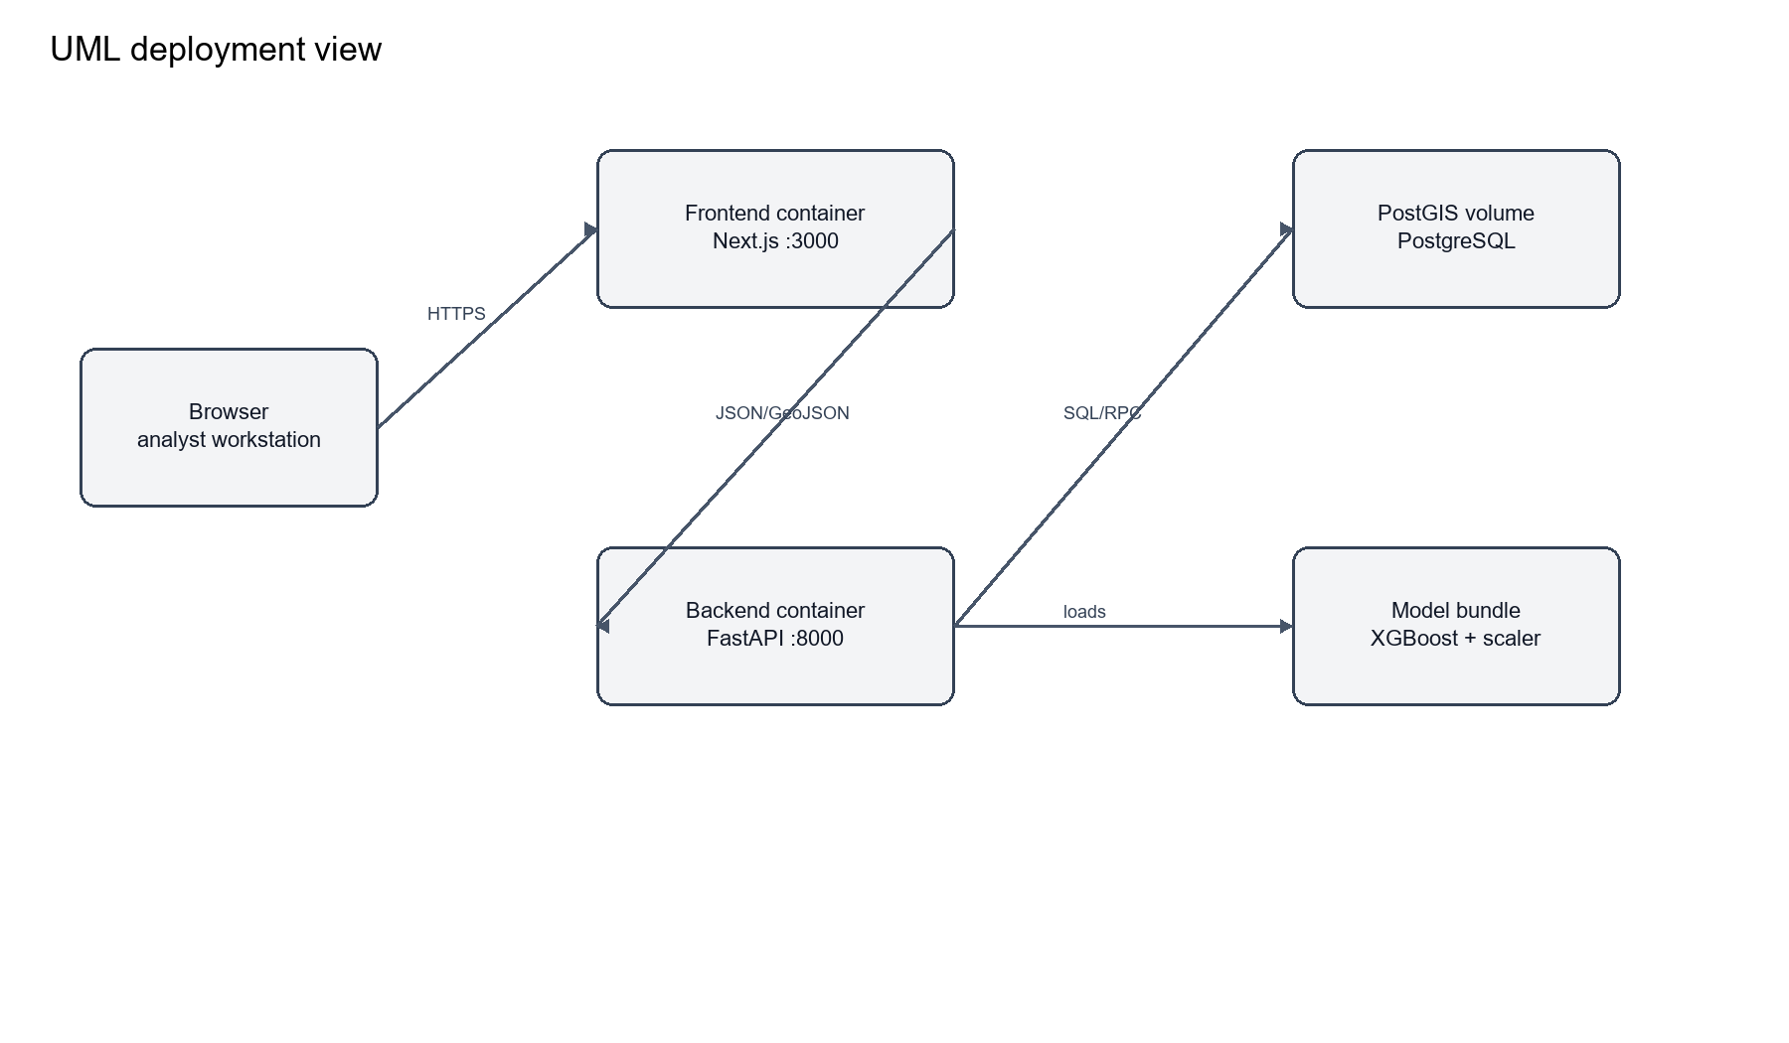
Figure 2.8 UML deployment view.

CHAPTER THREE: PROJECT DEVELOPMENT, TESTING AND DEPLOYMENT
This chapter sets out the planned implementation, testing and deployment work. It distinguishes activities that are proposed from results that will be reported after testing.

3.1 Development Plan
The project will use a staged SDLC consistent with the supervision form. Requirements and design will be reviewed before implementation. Interface, API, spatial structures and model workflow will be developed feature by feature, followed by debugging and integration. Design Science Research will guide creation and evaluation of the decision-support artefact.

3.2 Data and Database Development
The database design will cover users, spatial grid cells, protected areas, management units, scenario history and audit metadata. Geometry columns and spatial indexes will support intersection queries. Ingestion will record source, date, coordinate system and transformations. Model integration will verify feature names, units, ordering and missing-value handling against the approved data dictionary.

3.3 Feature Development Plan
Feature | Planned implementation | Review evidence
Access and roles | Authentication flow, protected routes and account controls. | Role and access checks.
Baseline map | Load approved layers, filters and legends. | Map/source metadata review.
Scenario input | Collect geometry, units and supported changes. | Validation and interaction records.
Spatial selection | Query cells intersecting valid geometry. | Known-area query examples.
Prediction/comparison | Prepare features, infer and compare baseline. | Reproducible inputs and outputs.
History/export | Save scenario metadata and create permitted exports. | Record and export inspection.
Administration | Manage roles and review activity. | Role-specific workflow review.

3.4 Testing Plan
Testing will occur during feature work and after integration. Acceptance measures will be agreed during design review. Test data will be non-sensitive or appropriately authorized.
Level | Planned focus | Evidence
Unit/component | Validation, feature calculations, response formatting and permissions. | Input/output records and defect log.
Integration | Interface/API, API/spatial store and prediction connections. | Request traces and comparison checks.
Functional/system | Requirements FR1-FR10 and complete scenario workflow. | Requirement-to-test matrix.
Performance | Map loading and scenario response under agreed volume. | Timings and test environment.
Security | Authentication, roles, input handling and secret configuration. | Access review findings.
User acceptance | Task completion and clarity feedback from selected users. | Consent-aware feedback summary.

3.4.1 Acceptance Measures
- Each functional requirement will have a recorded test case before final evaluation.
- Malformed geometry or unsupported input will be rejected with a clear message.
- Baseline records will remain unchanged after scenario processing.
- Repeated runs with identical data, model and inputs will meet an agreed numerical tolerance.
- Performance thresholds will be agreed with the supervisor and documented with the environment.
- Usability feedback will be summarized without overstating the sample.

3.5 Deployment Plan
At Milestone 5, the application will be prepared for a simulated or approved hosting environment. Configuration will cover service URLs, database access, model files, credentials and roles. Health checks and core workflows will be verified. The hosting choice will consider cost, availability, data sensitivity and institutional approval. Public release or live conservation feeds will require authorization.
Activity | Planned result
Environment preparation | Document runtime, dependencies and configuration.
Secure configuration | Keep secrets outside source; apply roles and database permissions.
Release checks | Verify core screens, baseline access and a sample scenario.
Operational notes | Document backup, monitoring, limitations and rollback steps.
Supervisor review | Present evidence and Chapter Three record for assessment.

3.6 Maintenance Considerations
Future maintenance will include dependency updates, source refreshes, model revalidation and access-control review. Changes to model features or spatial schemas will require corresponding updates to the data dictionary, tests and user documentation.
Field | Type / unit | Meaning and use | Status
cell_id | integer | Stable identifier for a grid-cell record. | Stored
geom | Polygon, EPSG:4326 | Grid-cell boundary used for spatial intersection. | Stored
centroid | Point, EPSG:4326 | Representative point used for bounding-box and enrichment queries. | Stored
management_unit | text | Conservancy or management area associated with the cell. | Stored
baseline_lion_density | float | Baseline density or model input recorded for the cell; interpretation must follow the approved model documentation. | Stored
year | integer | Observation or reference year for the cell record. | Stored
prey_density | float, source unit | Cached ecological proxy from approved prey data. | Optional cache
annual_rainfall_mm | float, mm | Annual rainfall used for enrichment or scenario analysis. | Optional cache
hwc_risk_score | float, 0-1 | Derived human-wildlife conflict risk score. | Derived
dist_to_protected_km | float, km | Distance from the cell to the nearest protected area. | Derived / stored
Table 4.5 Model feature families
Family | Representative fields | Interpretation
Night-light statistics | all_mean_mean, all_mean_std, all_skew_mean, all_kurtosis_mean, all_variance_mean | Summary statistics describing intensity and distribution of night-light observations.
Night-light trend | longterm_slope_mean, longterm_intercept_mean, longterm_r2_mean, licorr_slope_mean | Long-term level, slope and fit indicators.
Population and continuity | pop2018_mean, primary_acf_mean, secondary_acf_mean, prominence fields | Population proxy and temporal continuity features.
Seasonality | ann_amp_mean, ann_cv_mean, ann_peak_month_mean, ann_trend_mean | Annual amplitude, variation, peak timing and trend.
Ecological proxies | density_code, hist_lag1, hist_lag2, cheetah_abundance | Encoded or lagged ecological predictors used by the model.
Table 4.6 User, scenario and audit entities
Entity | Key fields | Purpose
users | id, email, role, is_active, created_at | Identity, authorisation and account state.
api_keys | id, user_id, key_hash, is_active, last_used | Programmatic access without storing plaintext keys.
scenario_history | id, user_id, modified_features, request_data, scenario_geojson, baseline_total_lions, predicted_total_lions, delta_percent | Reproducible record of a scenario request and its result.
historical_stats | management_unit, year, population_estimate | Time-series values used in trends and comparison views.
audit_logs | user_id, action, resource_type, resource_id, details, created_at | Trace of privileged or material system actions.
protected_areas | site_name, designation, iucn_category, area_km2, geom | Protected-area boundaries and attributes.

CHAPTER FOUR: TECHNICAL IMPLEMENTATION AND OPERATIONAL DOCUMENTATION
This chapter records the implementation tools and operational controls that make the proposed platform reproducible. The descriptions are tied to the current project structure and distinguish implemented components from planned integrations.

4.1 Map and Geospatial Workspace
The MapLibre GL JS canvas, configured with Mapbox styles and tiles, is the primary working surface for Seka Kama. The web client is built with Next.js and React. MapLibre GL JS provides the map renderer and camera controls, while react-map-gl supplies the React integration. Mapbox Draw supports user-defined polygons and other geometry inputs. Deck.gl is used for GPU-assisted rendering of dense grid-cell layers and derived spatial overlays. Kepler.gl is retained for exploratory visual analysis where an analyst needs rapid layer inspection. Recharts provides compact trend and comparison charts beside the map. These tools serve different purposes: MapLibre GL JS renders the Mapbox basemap, @mapbox/mapbox-gl-draw captures the area of interest, Deck.gl renders analytical layers, and Recharts explains the selected results.
The MapLibre GL JS layer workflow should remain understandable when a layer is hidden or unavailable. Each layer therefore has a name, source date, unit, visible range and provenance note. Scenario changes are drawn in a separate style from baseline observations, and the legend states whether a value is observed, derived or predicted. Sensitive wildlife locations are generalized or withheld according to the user role.
Table 4.1 MapLibre GL JS, Mapbox and interface tools
Tool | Role in the platform | Primary output | Control to document
Next.js and React | Application shell, routing and stateful workspace | Browser interface | Version, build command and environment variables
MapLibre GL JS and react-map-gl | Base map, navigation and layer display | Interactive map canvas | Coordinate reference system and tile source
Mapbox Mapbox Draw | Area-of-interest geometry and editing | GeoJSON geometry | Geometry validation and permitted bounds
Deck.gl, Kepler.gl and Recharts | Analytical layers, exploratory inspection and charts | Grid layers, summaries and trends | Layer metadata, scales and units

4.2 Spatial Data Pipeline
Spatial data enters the system through controlled ingestion scripts and database loaders. The current repository includes scripts for rainfall, historical trends, protected areas, land cover, NDVI and grid-cell imports. The target store is PostGIS, accessed through the Supabase client in the backend services. During ingestion, each layer is checked for geometry validity, coordinate reference system, temporal coverage, field names, units and source provenance. A layer is not made available to scenario analysis until these checks pass.
The analytical unit is the grid cell. A baseline request can be filtered by management unit, year or bounding box. A scenario request supplies GeoJSON geometry; the spatial service converts it to a database query, identifies intersecting cells and returns a copy of the baseline features for processing. The baseline record remains read-only throughout this operation.

4.3 Prediction and Scenario Services
The backend is a Python FastAPI service. Authentication and API routing are separated from the domain services. The spatial service retrieves cells and protected areas; the ecological data service enriches cells with approved NASA POWER and GBIF values when those integrations are enabled; the prediction service loads the XGBoost model, StandardScaler and feature-name list; and the scenario processor applies only permitted feature modifications before inference. The response builder returns baseline and predicted totals, the difference between them, affected management units, the model version and a GeoJSON representation for the map.
A narrative service may provide an ecological explanation through the configured NVIDIA NIM endpoint. The narrative is supplementary to the numeric result. If the language service is unavailable, the workflow returns a rule-based explanation and records that fallback. The system does not present generated narrative as an observed field event.
Table 4.2 Core implementation components
Component | Repository location | Responsibility
FastAPI application | backend/api and backend/main.py | Routes, validation, authentication and response handling
Spatial service | backend/services/spatial_service.py | Geometry conversion, intersections and spatial queries
Prediction service | backend/services/prediction_service.py | Feature preparation, scaling and XGBoost inference
Ecological data service | backend/services/ecological_data_service.py | NASA POWER and GBIF enrichment workflows
Supabase/PostGIS access | backend/core/database.py and SQL scripts | Persistent spatial, user and audit records
Next.js client | web-app/seka_kama/app and components | Map workspace, scenario controls and result views

4.4 API and Data Contracts
The public contract is expressed through versioned HTTP endpoints. Health and status checks report database and model availability. Baseline endpoints return GeoJSON FeatureCollections with cell identifiers, management units, model features and dates. The scenario endpoint accepts a geometry, permitted feature modifications, optional management units, an optional user query and a simulation horizon. The response includes a scenario identifier, baseline and predicted totals, delta values, affected units, model metadata and visualization GeoJSON. Validation errors use a clear status code and message; a failed external enrichment is marked as a degraded enrichment rather than silently treated as a measured value.

4.5 Deployment and Configuration
The supplied Docker Compose configuration separates the PostGIS database, FastAPI backend and Next.js frontend. The database persists its data in a named volume. The backend receives the database URL, service key and model path through environment variables, and the frontend is exposed on its own service port. Production configuration must replace development secrets, restrict CORS origins, enable HTTPS at the edge and configure health checks before the system is exposed to users.
Table 4.3 Deployment controls
Area | Required control | Evidence to retain
Secrets | Keep database keys, JWT secrets and external API keys outside source code | Redacted environment template and deployment record
Database | Use PostGIS indexes, backups and a documented migration sequence | Migration log and backup test
Model files | Pin model, scaler and feature-name versions together | Model manifest and checksum
Web services | Run health checks and use HTTPS with restricted CORS | Health-check output and configuration review
Audit and recovery | Record privileged actions and define rollback ownership | Audit sample and recovery runbook

4.6 Reproducible map implementation specification
The Next.js/React map workspace is implemented as a composition of named libraries, rather than as a single mapping package. This distinction matters because each library owns a different part of the interaction model. The following specification is taken from web-app/seka_kama/package.json and the component files in web-app/seka_kama/components. A library is listed as an implementation dependency only where the repository manifest records it; the document does not infer capabilities from a package name alone.
Table 4.7 Exact map and visualisation dependencies
Library and version | Integration point | Documented responsibility | Evidence source
maplibre-gl ^5.24.0 | Map canvas and style runtime | Renders the interactive basemap, camera, sources and map layers. | web-app/seka_kama/package.json; components/KeplerMap.tsx and SekaMap.tsx
react-map-gl ^8.1.1 | React map wrapper | Connects React state and lifecycle to the map instance used by the workspace. | web-app/seka_kama/package.json; map components
@mapbox/mapbox-gl-draw ^1.5.1 | Geometry editing control | Captures the user-defined area of interest as GeoJSON for scenario requests. | web-app/seka_kama/package.json; scenario UI components
deck.gl 9.2.11 | Analytical rendering layer | Provides GPU-accelerated layers for dense grid-cell and spatial overlays. | web-app/seka_kama/package.json; deck.gl overrides
kepler.gl ^3.3.0-alpha.0 | Exploratory geospatial view | Supports exploratory layer inspection and map-based analysis where enabled by the application. | web-app/seka_kama/package.json
recharts ^2.15.3 | Chart components | Renders time-series, comparison and summary charts alongside the map. | web-app/seka_kama/package.json; TrendChart.tsx
lucide-react ^0.473.0 | Interface icons | Provides consistent icons for controls and navigation; it is not a spatial analysis library. | web-app/seka_kama/package.json
The map-to-model contract is explicit. The draw control produces GeoJSON; the client sends the geometry to the FastAPI scenario route; the backend converts it to a spatial query, identifies intersecting grid cells and returns result GeoJSON for rendering by MapLibre GL JS and Deck.gl. Baseline, predicted and scenario layers must be styled separately so a reader can distinguish observed or stored values from model output. The implementation must also expose the source date, model version, feature units and missing-data state in the layer metadata or result panel.

4.7 Exact model feature inventory
The prediction service loads 43 feature names from backend/models/feature_names.pkl. These names are the authoritative input order for the scaler and XGBoost model. The repository does not provide a complete scientific definition or unit for every feature; therefore the dictionary below records the name and family and marks the unit as requiring confirmation where the source schema does not define it. This prevents a software label from being presented as an ecological measurement without evidence.
Table 4.8 Authoritative model feature inventory
Index | Feature name | Feature family | Unit / definition status
1 | longterm_slope_mean | Long-term / correlation trend | Unit requires confirmation from data dictionary / source product
2 | longterm_slope_std | Long-term / correlation trend | Unit requires confirmation from data dictionary / source product
3 | all_skew_mean | Night-light distribution statistic | Unit requires confirmation from data dictionary / source product
4 | all_skew_std | Night-light distribution statistic | Unit requires confirmation from data dictionary / source product
5 | all_mean_mean | Night-light distribution statistic | Unit requires confirmation from data dictionary / source product
6 | all_mean_std | Night-light distribution statistic | Unit requires confirmation from data dictionary / source product
7 | all_kurtosis_mean | Night-light distribution statistic | Unit requires confirmation from data dictionary / source product
8 | all_kurtosis_std | Night-light distribution statistic | Unit requires confirmation from data dictionary / source product
9 | all_median_mean | Night-light distribution statistic | Unit requires confirmation from data dictionary / source product
10 | all_median_std | Night-light distribution statistic | Unit requires confirmation from data dictionary / source product
11 | all_variance_mean | Night-light distribution statistic | Unit requires confirmation from data dictionary / source product
12 | all_variance_std | Night-light distribution statistic | Unit requires confirmation from data dictionary / source product
13 | licorr_slope_mean | Long-term / correlation trend | Unit requires confirmation from data dictionary / source product
14 | licorr_slope_std | Long-term / correlation trend | Unit requires confirmation from data dictionary / source product
15 | longterm_intercept_mean | Long-term / correlation trend | Unit requires confirmation from data dictionary / source product
16 | longterm_intercept_std | Long-term / correlation trend | Unit requires confirmation from data dictionary / source product
17 | longterm_r2_mean | Long-term / correlation trend | Unit requires confirmation from data dictionary / source product
18 | longterm_r2_std | Long-term / correlation trend | Unit requires confirmation from data dictionary / source product
19 | pop2018_mean | Population / temporal continuity proxy | Unit requires confirmation from data dictionary / source product
20 | pop2018_std | Population / temporal continuity proxy | Unit requires confirmation from data dictionary / source product
21 | primary_acf_mean | Population / temporal continuity proxy | Unit requires confirmation from data dictionary / source product
22 | primary_acf_std | Population / temporal continuity proxy | Unit requires confirmation from data dictionary / source product
23 | primary_prominence_mean | Population / temporal continuity proxy | Unit requires confirmation from data dictionary / source product
24 | primary_prominence_std | Population / temporal continuity proxy | Unit requires confirmation from data dictionary / source product
25 | secondary_acf_mean | Population / temporal continuity proxy | Unit requires confirmation from data dictionary / source product
26 | secondary_acf_std | Population / temporal continuity proxy | Unit requires confirmation from data dictionary / source product
27 | secondary_prominence_mean | Population / temporal continuity proxy | Unit requires confirmation from data dictionary / source product
28 | secondary_prominence_std | Population / temporal continuity proxy | Unit requires confirmation from data dictionary / source product
29 | ann_amp_mean | Annual seasonality statistic | Unit requires confirmation from data dictionary / source product
30 | ann_amp_std | Annual seasonality statistic | Unit requires confirmation from data dictionary / source product
31 | ann_cv_mean | Annual seasonality statistic | Unit requires confirmation from data dictionary / source product
32 | ann_cv_std | Annual seasonality statistic | Unit requires confirmation from data dictionary / source product
33 | ann_peak_month_mean | Annual seasonality statistic | Unit requires confirmation from data dictionary / source product
34 | ann_peak_month_std | Annual seasonality statistic | Unit requires confirmation from data dictionary / source product
35 | ann_trend_mean | Annual seasonality statistic | Unit requires confirmation from data dictionary / source product
36 | ann_trend_std | Annual seasonality statistic | Unit requires confirmation from data dictionary / source product
37 | ann_mean_mean | Annual seasonality statistic | Unit requires confirmation from data dictionary / source product
38 | ann_mean_std | Annual seasonality statistic | Unit requires confirmation from data dictionary / source product
39 | density_code | Encoded density feature | Unit requires confirmation from data dictionary / source product
40 | hist_lag1 | Historical lag feature | Unit requires confirmation from data dictionary / source product
41 | hist_lag2 | Historical lag feature | Unit requires confirmation from data dictionary / source product
42 | cheetah_abundance | Ecological proxy | Unit requires confirmation from data dictionary / source product
43 | dist_to_protected_km | Spatial distance feature | km for distance

4.8 Methodological limits and unresolved definitions
The production map provider is Mapbox. The application uses MapLibre GL JS as the client renderer with the approved Mapbox style, tiles and access configuration. Mapbox attribution, token handling and licensing conditions must be retained in the deployment configuration and user-facing map view.

CHAPTER FIVE: CONCLUSIONS AND RECOMMENDATIONS
This chapter records the conclusions and recommendations supported by the design and the evidence available at the time of submission.

5.1 Conclusion
The project will design and evaluate a geospatial decision-support platform for reviewing conservation scenarios in the Greater Mara. Its planned contribution is a workflow that links an area of interest, approved baseline evidence, modelled comparison and readable outputs. The platform will be useful only to the extent that data and model behaviour are validated and communicated. Final conclusions will be based on recorded evaluation evidence after the milestones are completed.

5.2 Recommendations
- Confirm data access, licensing, provenance and update frequency before implementation.
- Agree on ecological interpretation and model evaluation measures with qualified practitioners.
- Keep predicted values separate from observed incident records; show data dates, model version and limitations.
- Protect precise wildlife locations and sensitive community or incident information.
- Conduct user-acceptance review with representative conservation and technical users before operational adoption.
- Treat live sensor integration as a later extension unless access and governance are established within scope.

5.3 Areas for Further Work
Further work may examine additional species, longer time series, validated field observations, uncertainty visualization, mobile reporting and authorized sensor integrations. Each extension will require independent data, privacy and model validation.
Allen Institute for AI. (2026). What is EarthRanger and how does it work? EarthRanger Support. https://support.earthranger.com/en_US/what-is-earthranger-and-how-does-it-work
Esri. (n.d.). Conservation planning and prioritization. https://www.esri.com/en-us/industries/conservation/focus-areas/planning
World Bank. (2022). Spatial Management and Reporting Tool (SMART). https://thedocs.worldbank.org/en/doc/43c89c4a946e031980277302e3072960-0320052022/original/poaching-spatial-management-and-reporting-tool-smart.pdf

REFERENCES
Bauer, H., Chapron, G., Nowell, K., Henschel, P., Funston, P., Hunter, L. T. B., Macdonald, D. W., & Packer, C. (2015). Lion (Panthera leo) populations are declining rapidly across Africa, except in intensively managed areas. Proceedings of the National Academy of Sciences, 112(48), 14894-14899. https://doi.org/10.1073/pnas.1500664112
Chen, T., & Guestrin, C. (2016). XGBoost: A scalable tree boosting system. In Proceedings of the 22nd ACM SIGKDD International Conference on Knowledge Discovery and Data Mining (pp. 785-794). ACM. https://doi.org/10.1145/2939672.2939785
Grieves, M., & Vickers, J. (2017). Digital twin: Mitigating unpredictable, undesirable emergent behavior in complex systems. In F.-J. Kahlen, S. Flumerfelt, & A. Alves (Eds.), Transdisciplinary perspectives on complex systems (pp. 85-113). Springer. https://doi.org/10.1007/978-3-319-38756-7_4
Hämäläinen, M. (2020). Smart city development with digital twin technology. In Proceedings of the 33rd Bled eConference (pp. 1-15). University of Maribor Press. https://doi.org/10.18690/978-961-286-362-3.7
Hevner, A. R., March, S. T., Park, J., & Ram, S. (2004). Design science in information systems research. MIS Quarterly, 28(1), 75-105. https://doi.org/10.2307/25148625
International Union for Conservation of Nature. (2021). Panthera leo (errata version published in 2021). The IUCN Red List of Threatened Species 2021: e.T15951A215765030. https://doi.org/10.2305/IUCN.UK.2021-1.RLTS.T15951A215765030.en
Nikkhah, A., Rezapour, S., & Emadi, M. (2021). Applications of smart sensors and IoT in precision agriculture: A review. Journal of Agricultural Science and Technology, 23(1), 1-12.
Peffers, K., Tuunanen, T., Rothenberger, M. A., & Chatterjee, S. (2007). A design science research methodology for information systems research. Journal of Management Information Systems, 24(3), 45-77. https://doi.org/10.2753/MIS0742-1222240302
Pettorelli, N., Laurance, W. F., O’Brien, T. G., Wegmann, M., Nagendra, H., & Turner, W. (2014). Satellite remote sensing for applied ecologists: Opportunities and challenges. Journal of Applied Ecology, 51(4), 839-848. https://doi.org/10.1111/1365-2664.12261
United Nations Environment Programme World Conservation Monitoring Centre. (2023). World Database on Protected Areas (WDPA). https://www.protectedplanet.net
Zetech University. (n.d.). Project supervision form (F-7-53, Issue/Rev. 1/0).

APPENDIX A: PROPOSED SCREEN INVENTORY
Screen | Main elements | User task
Sign-in | Credentials and access notice. | Enter workspace.
Analysis dashboard | Map, legend, filters, scenario panel and baseline summary. | Review conditions and choose an area.
Scenario configuration | Geometry, management unit, changes and description. | Define a reproducible scenario.
Scenario results | Map, comparison, explanation and export. | Interpret and retain decision material.
History and reports | Saved scenarios, dates, filters and exports. | Review prior work.
Administration | Roles, access settings and activity records. | Maintain controlled access.

APPENDIX B: ILLUSTRATIVE SCENARIO REQUEST
{
"geometry": {"type": "Polygon", "coordinates": []},
"feature_modifications": {"ndvi_mean": -0.08},
"management_units": ["approved-unit-id"],
"description": "Illustrative habitat-change scenario"
}
The geometry and feature values are illustrative only; the final schema and supported variables will be confirmed against approved data and model requirements.

